Name: ADWAIT S PURAO

UID: 2021300101

# Branch: Comps B (Batch B2)

**R-L-C Series Resonance**

Page 1

**CIRCUIT DIAGRAM:**

**OBSERVATIONS:**

R = 100 Ω, L = 3.3 mH, C = 0.1 µF

At resonance frequency, VL = 6.5 V, VC = 7.22V, V = 3.61V

|  |  |  |
| --- | --- | --- |
| **Sr. No.** | **Frequency(kHz)** | **Current (mA)** |
| 1 | 1.043 | 0.054 |
| 2 | 2.006 | 0.163 |
| 3 | 3 | 0.275 |
| 4 | 5 | 0.345 |
| 5 | 7 | 0.354 |
| 6 | 8.79 | 0.349 |
| 7 | 10 | 0.306 |
| 8 | 11 | 0.268 |
| 9 | 15 | 0.224 |
| 10 | 17 | 0.185 |

**CALCULATIONS:**

In an RLC series circuit impedance is given by . The frequency at

which the power factor of the circuit is unity i.e., the reactive part in the impedance becomes zero is called resonant frequency. So, at resonance .

Hence,



or



At resonance, the current is maximum (=V/R) whereas impedance Z is minimum (=R). The bandwidth of the circuit is given by a band of frequencies that lies between the two points at which the current is 1/√2 times the current at the resonant frequency.

The voltage magnification in a series resonant circuit is expressed in terms of quality factor.



and



= (VL or VC) / V

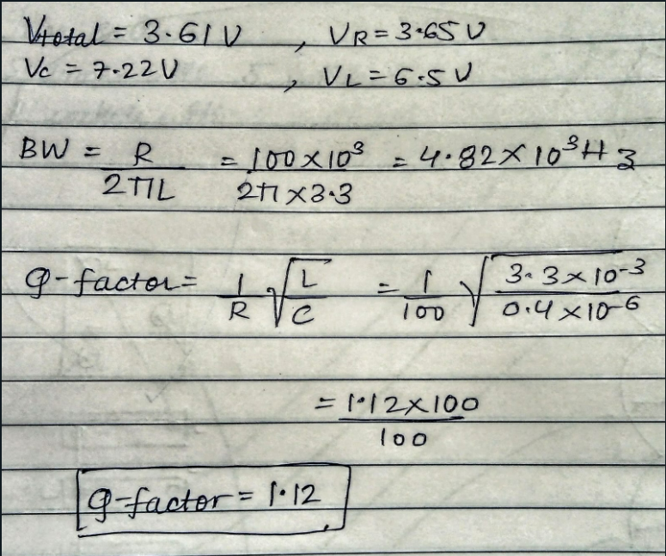

**EXPERIMENT NO.: 6 DATE: 18 / 07 / 2022**

**Resonance in RLC series circuit**

**AIM:**

To verify resonance frequency, bandwidth, and Q-factor of the given R-L-C series circuit.

**APPARATUS AND COMPONENTS REQUIRED:**

Resistor, Inductor, Capacitor, Signal Generator, Milliammeter, breadboard, connecting wires.

**THEORY:**

**What is resonance in R-L-C circuit and what is the condition to achieve it?**

Resonance in AC circuits implies a special frequency determined by the values of the resistance, capacitance, and inductance. For series resonance the condition of resonance is straightforward, and it is characterized by minimum impedance and zero phase.

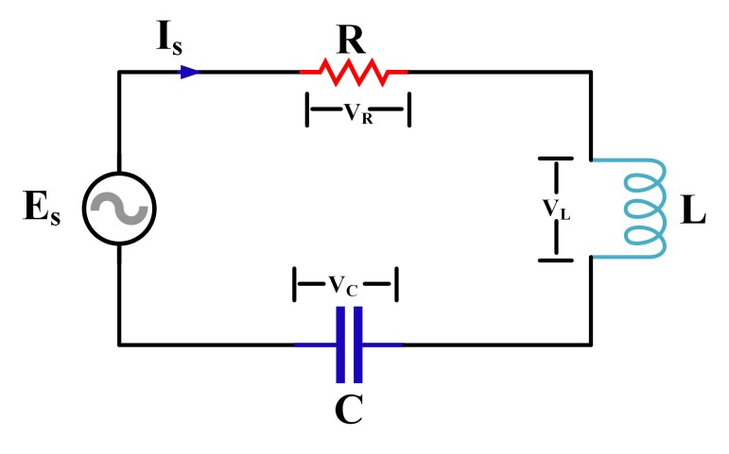

**What is the relation between bandwidth and selectivity factor?**

The Selectivity factor, Q of a series resonance circuit is the ratio of the centre frequency to the bandwidth. Q = fc / BW so if the circuit has a narrow bandwidth, its selectivity will be high, and if it has a wide bandwidth its selectivity will be low.

**What is the significance of Q-factor?**

The Q factor implies energy losses within a resonant device that might be anything from a mechanical pendulum, an entity in a mechanical structure, or an electrical circuit, such as a resonant circuit. Q-factor shows the energy loss due to the quantity of energy contained in the design. Thus, the larger the Q factor, the lower the rate of energy loss, and hence the slower the oscillations.

**List the applications of resonance**

1. Radio Transmissions and Television Broadcasts

Most of us will experience using a resonant circuit as we attempt to tune into a radio frequency or pick up an analogue television station. In doing so, we’re adjusting the frequency so that the elements of the resonant circuit are in equilibrium. In the radio receiver, the tuning circuit is connected to the vehicle’s antenna. The antenna receives electromagnetic waves of varying frequencies transmitted by different stations within a specific range. As you turn the dial, the frequencies generated in the antenna will have the same frequency as a local radio station. This means the tuning circuit in the radio receiver will only allow the current that has a matching frequency to that of the circuit to pass which in turn allows you to listen to a crystal-clear signal of your selected station.

1. Signal Processing and Communication Systems

Television and radio signals are an example of an application of resonance effect that many of us are most familiar with, but there are many other applications in which resonance circuits play an important role. Case in point: fibre optic data transmission. Fibre optics communication is used to transmit video, telemetry, and voice data all over the globe. Infrared light is sent through an optical cable, with the light carrying information—otherwise known as a carrier wave. The reason fibre is used instead of electrical cables is that it’s immune to electromagnetic interference. It’s also better at accommodating high bandwidth and longer distances.

1. Voltage Magnification

When the total circuit impedance is less than either the capacitive or inductive reactance at a resonant frequency, the supply voltage (developed across the circuit resistance) will be less than either of the opposing reactive voltages VC or VL. This effect, where the internal component reactive voltages are greater than the supply voltage is known as voltage magnification and there are several benefits associated with it. For example, when a circuit is configured in series, it can be used to magnify the voltage amplitude of a signal When it comes to AC signal voltages, voltage magnification can be done passively, meaning the amplitude of the signal can be increased without a commensurate increase in power consumption.

Voltage magnification is very useful and is most notably used in radio antennas. Radio receivers magnify the voltage amplitude of the signal voltage that is being received before it’s fed to the transistor amplifiers in the circuit. Also, voltage magnification doesn’t require an external power supply, making it even more beneficial.

1. Induction Heating

An induction heating system relies on access to a power supply, a circuit that contains matching impedance, a resonant circuit, and an applicator. In this instance, the resonant circuit is generally configured in parallel; within this circuit, the capacitors and inductors will store electrostatic and electromagnetic energy respectively. Once the circuit is at its resonant frequency, the elements will transfer power back and forth. Since the circuit is configured in parallel, this conversion will occur at a very high current. Energy is lost in the form of heat in the capacitor which results in the creation of induction heating. Induction heating is used within many industrial processes and is a quick way to heat metals. Technicians can use induction heating devices to create an electrical current in the metal object, generating heat. This is useful because then the metal becomes pliable enough to be used for machining.

1. Oscillator Circuits

A crystal oscillator is an electronic oscillator circuit that is used to create an electrical signal with a given frequency. This frequency is commonly used to keep track of time and is used in a number of different timepieces. The crystal oscillator works in conjunction with a principle known as the inverse piezoelectric effect. Simply put, an electrical field produces a mechanical deformation within the crystal material. This deformation produces a vibration of the material’s mechanical resonance to produce a very specific frequency. Common applications of oscillator circuits include alarms or buzzers within clocks or other devices. They can even be found in recreational or decorative products such as dance lights.

**PROCEDURE:**

1. Connect the Series RLC circuit as shown in the circuit diagram.
2. Make sure that the milliammeter is in series with the circuit.
3. Keep the values fixed of R, L, and C.
4. Keep varying frequency of the input signal from zero onwards
5. Measure frequency ‘f’ and current ‘I’ in mA.
6. Tabulate readings and draw the graph of frequency v/s current.
7. Calculate the value of bandwidth using the formula B.W. = fH-fL from the graph.
8. Measure VC or VL and supply voltage V at resonance to obtain Q as VL / V
9. Implement the circuit using Sequel and verify answers of current, bandwidth, and Qfactor using simulation.

**RESULT:**

|  |  |  |
| --- | --- | --- |
| **Parameter** | **Theoretical** | **By Observation** |
| f0 (kHz) | 8.81 | 8.79 |
| Bandwidth (kHz) | 4.85 | 4.82 |
| Quality factor | 1.12 | 1.12 |

**GRAPH:**

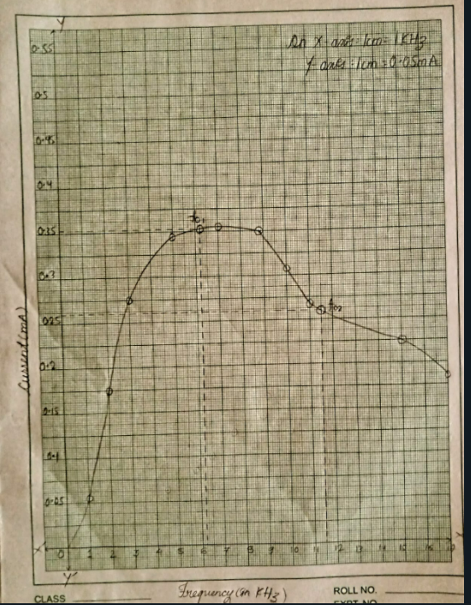

**CONCLUSION:**

